Raspberry Pi Pico Introduction

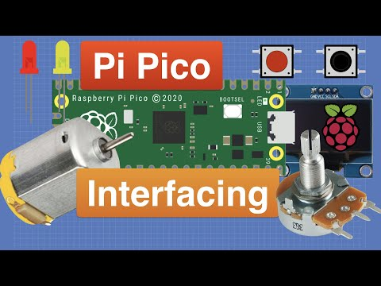

Pico is a board with powerful functions and low price as well as small size. Its dimension is [similar to](C:/Users/NINGMEI/AppData/Local/youdao/dict/Application/9.0.1.1/resultui/html/index.html" \l "/javascript:;) Arduino Nano, measuring 21mm x 51mm.

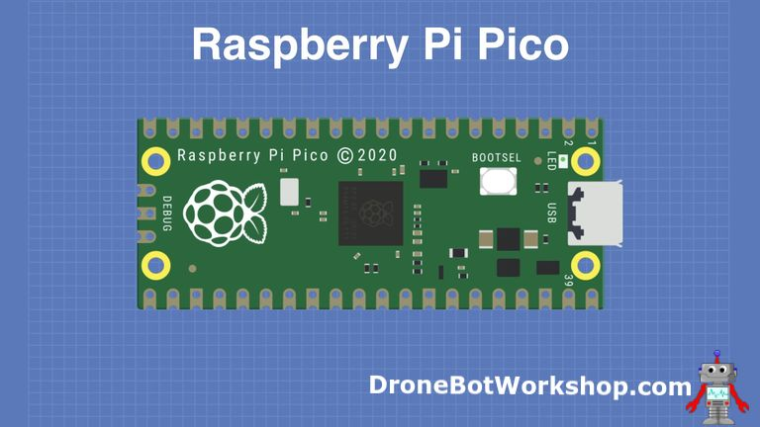

Raspberry Pi Pico is a low-cost, high-performance microcontroller with flexible digital interfaces. It owns the Raspberry Pi's RP2040 microcontroller chip, a 133mhz dual-core Arm Cortex M0 + processor, an embedded 264KB SRAM, a 2MB onboard flash memory as well as 26 multi-functional GPIO pins.

For software development, you can use Raspberry Pi's C/C++SDK or MicroPython, and we use the latter in this tutorial.

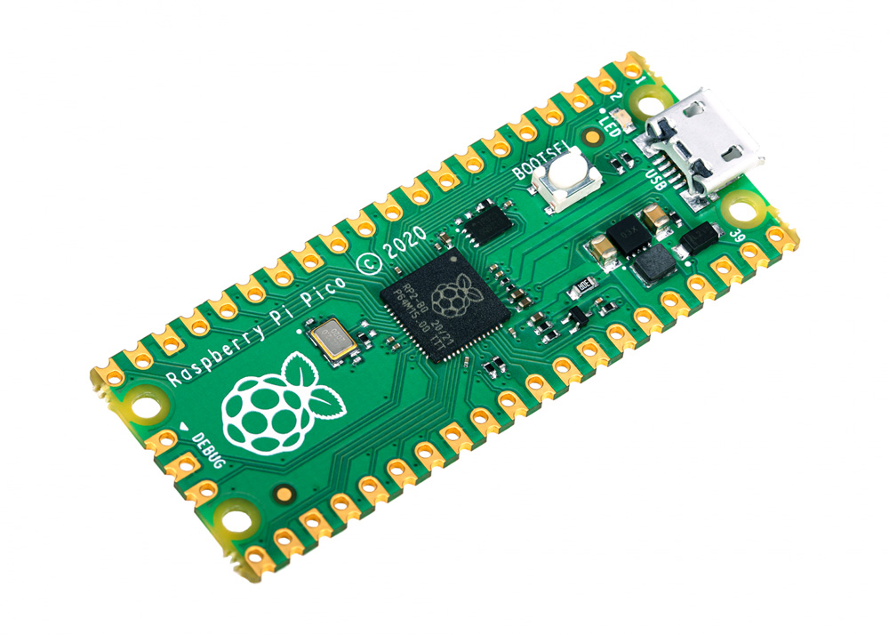

Bare board has no pins and needs to be welded.  This is a well made circuit board and can also be welded directly to a printed circuit board as a SMD component.

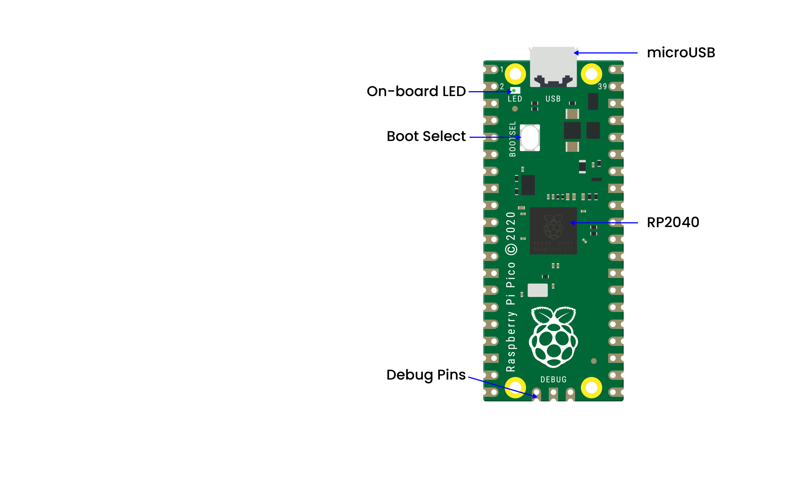

The main function of the board is the microUSB connector.  It is used both for communication and to power the Pico.

An onboard LED is installed next to the microUSB connector, which is internally connected to GPIO pin 25 and it is the only LED on the entire Pico board.

The start button is mounted slightly below the LED, which empowers to change the Pico's startup mode so that we can seek to load MicroPython on it for drag-and-drop programming.

At the bottom of the board, we will see three connection points for the serial Debug option.

In the middle of the board is the "brain" of the entire board -- the RP2040 MCU, which enable to support 16MB of off-chip flash memory but it's only 4MB in Pico.

– Dual-core 32-bit ARM Cortex-M0 + processor  
– Running at 48MHz but can be overclocked to 133MHz  
– 30GPIO pins(26 exposed)  
– Support USB host or device mode   
– 8 Programmable I/O (PIO) state machine

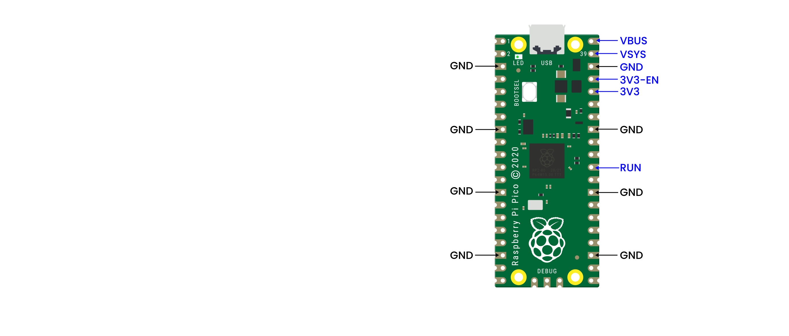

The Pico is a 3.3V logic device, which can be powered from a series of power supplies thanks to a built-in voltage converter and voltage regulator.

GND -- Ground wire

VBUS–––This is the power supply for the microUSB bus 5 V. If the Pico is not powered by the microUSB connector, there will be no output.  
VSYS–––This is the input voltage, which ranges from 2 to 5 V.  The onboard voltage converter will change it to 3.3V for Pico.  
3V3–––This is the 3.3 volt output of the Pico internal regulator.  It can be used to power other components as long as the load is kept below 300ma.

3V3_EN–––You can use this input to disable the Pico's internal voltage regulator, thus shutting down the Pico and any components powered by it.   
RUN–––You can enable or disable the RP2040 microcontroller or reset it.

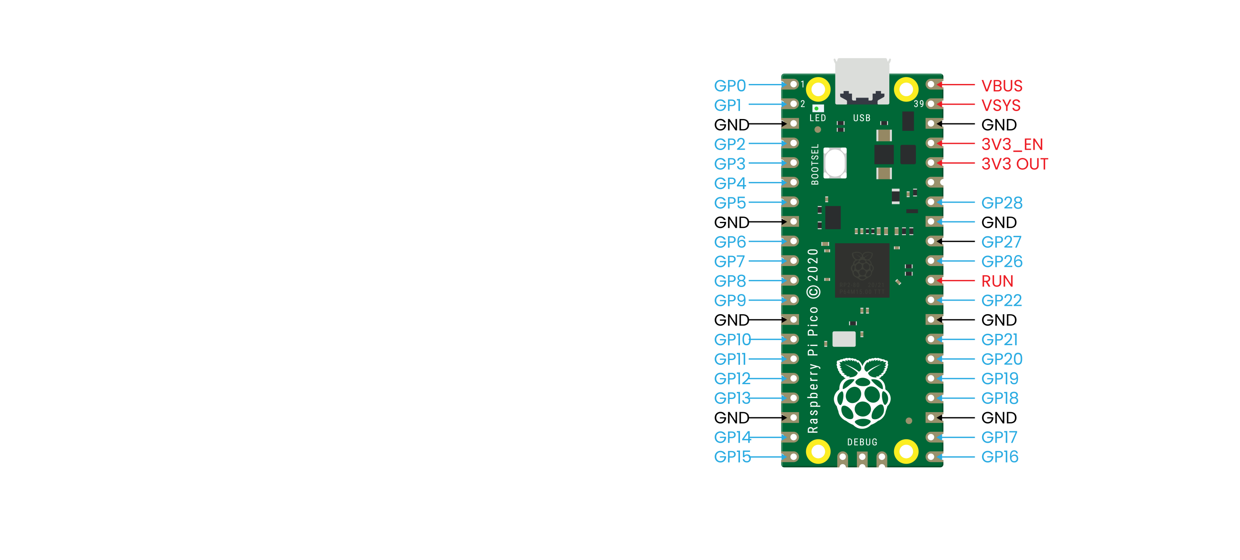

There are 26 bare GPIO connections on the Raspberry PI Pico board, which are arranged in a good order with "gaps" between GP22 and GP26 (these "missing" pins are used internally).  These pins have multiple functions and you can configure up to 16 pins for the PWM.

Furthermore, there are two I2C buses, two UART buses and two SPI buses, which can be configured using a variety of GPIO pins.

Pico contains three analog-to-digital converters, which are ADC0-GP26, ADC1-GP27, ADC2-GP28. It also includes an internal converter ADC-VREF for onboard temperature sensor.

Note: The ADC has a resolution of 12 bits.  But MicroPython maps the range to 16 bits, from 0 to 65535, and the microprocessor's operating voltage is 3.3V, meaning that 0 corresponds to 0V and 65535 to 3.3V.

You can also provide an external precision voltage reference on the ADC_VREF pins and the ADC_GND on pin 33 is used as the ground point for this reference point.

|  |
| --- |
| Raspberry Pi PICO [Configuration](C:/Users/NINGMEI/AppData/Local/youdao/dict/Application/9.0.1.1/resultui/html/index.html" \l "/javascript:;) |
| Dual-core Arm Cortex-M0 + @ 133MHz |
| 2 × UART、2 × SPI [controller](C:/Users/NINGMEI/AppData/Local/youdao/dict/Application/9.0.1.1/resultui/html/index.html" \l "/javascript:;) and 2 × I2C [controller](C:/Users/NINGMEI/AppData/Local/youdao/dict/Application/9.0.1.1/resultui/html/index.html" \l "/javascript:;) |
| Built-in 264KB SRAM and 2MB on-board flash memory |
| 16 PWM Channels |
| Up to 16MB of off-chip flash is supported via a dedicated QSPI bus |
| USB 1.1 Host and device support |
| DMA C[ontroller](C:/Users/NINGMEI/AppData/Local/youdao/dict/Application/9.0.1.1/resultui/html/index.html" \l "/javascript:;) |
| 8×Programmable I/O (PIO) state machine for custom peripheral support |
| 30 GPIO pins, and four of them can be used as analog inputs |
| Support USB mass storage startup mode of UF2 for drag-and-drop programming |

Pin Out

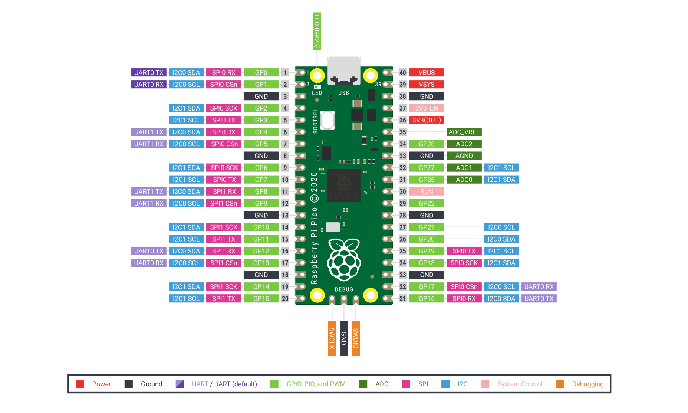

Related information:

https://www.raspberrypi.com/products/raspberry-pi-pico/